**Starting Out with Visual Basic 2015**

**Chapter 1 Programming Challenges**

**3. Sales Tax**

Step 1:

Purpose: Calculate the amount of sales tax and the total of a sale

Input: The amount of a retail sale and the sales tax rate

Process: Multiply the amount of the sale by the tax rate. Store the result in the tax variable. Add the amount of the sale to the amount in the tax variable, and store the result in the total variable.

Output: The amount of sales tax and the total amount of the sale.

Step 2:

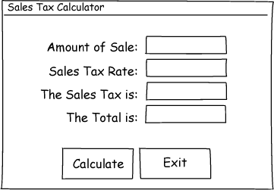

Step 3:

|  |  |
| --- | --- |
| Control Type | Name |
| Form | default |
| Label (for displaying "Amount of Sale:") | default |
| Label (for displaying "Sales Tax Rate:") | default |
| Label (for displaying "The Sales Tax is:") | default |
| Label (for displaying "The Total is:") | default |
| TextBox | txtAmount |
| TextBox | txtTaxRate |
| Label | lblTax |
| Label | lblTotal |
| Button | btnCalculate |
| Button | btnExit |

Step 4:

|  |  |
| --- | --- |
| Control | Text Property |
| Form | "Sales Tax Calculator" |
| Label (default name) | "Amount of Sale:" |
| Label (default name) | "Sales Tax Rate:" |
| Label (default name) | "The Sales Tax is:" |
| Label (default name) | "The Total is:" |
| txtAmount |  |
| txtTaxRate |  |
| lblTax |  |
| lblTotal |  |
| btnCalculate | "Calculate" |
| btnExit | "Exit" |

Step 5:

|  |  |
| --- | --- |
| Method Name | Description |
| btnCalculate_Click | Multiply the value in txtAmount.Text by the value in txtTaxRate.Text. Store the result in the tax variable. Add the value in txtAmount.Text to the value in the tax variable, and store the result in the total variable. Store the value in the tax variable in lblTax.Text. Store the value in the total variable in lblTotal.Text. |
| btnExit_Click | Ends the application. |

Step 6:

btnCalculate_Click

Flowchart:

Start

Multiply the value in txtAmount.Text by the value in txtTaxRate.Text. Store the result in the tax variable.

End

Add the value in txtAmount.Text to the value in the tax variable, and store the result in the total variable.

Store the value in the tax variable in lblTax.Text.

Store the value in the total variable in lblTotal.Text.

Pseudocode:

*tax = txtAmount.Text * txtTaxRate.Text.*

*total = txtAmount.Text + tax.*

*lblTax.Text = tax.*

*lblTotal.Text = total.*

btnExit_Click

Flowchart:

Start

End the application.

End

Pseudocode:

*End*